**ROMAN HISTORY**

**罗马史**

**Sources Week 3**

**Archaic Rome**

**Source 1: *Lapis Niger***

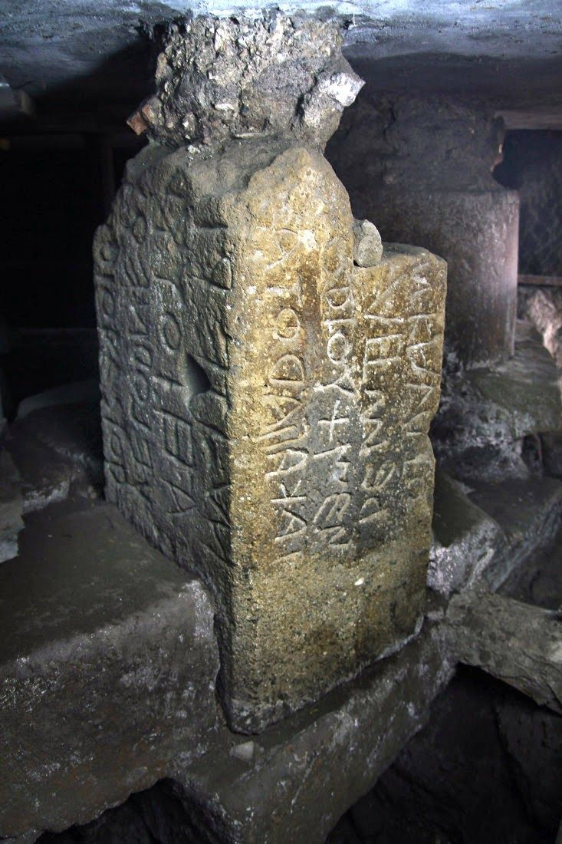

Figure 1 Lapis Niger

Below:

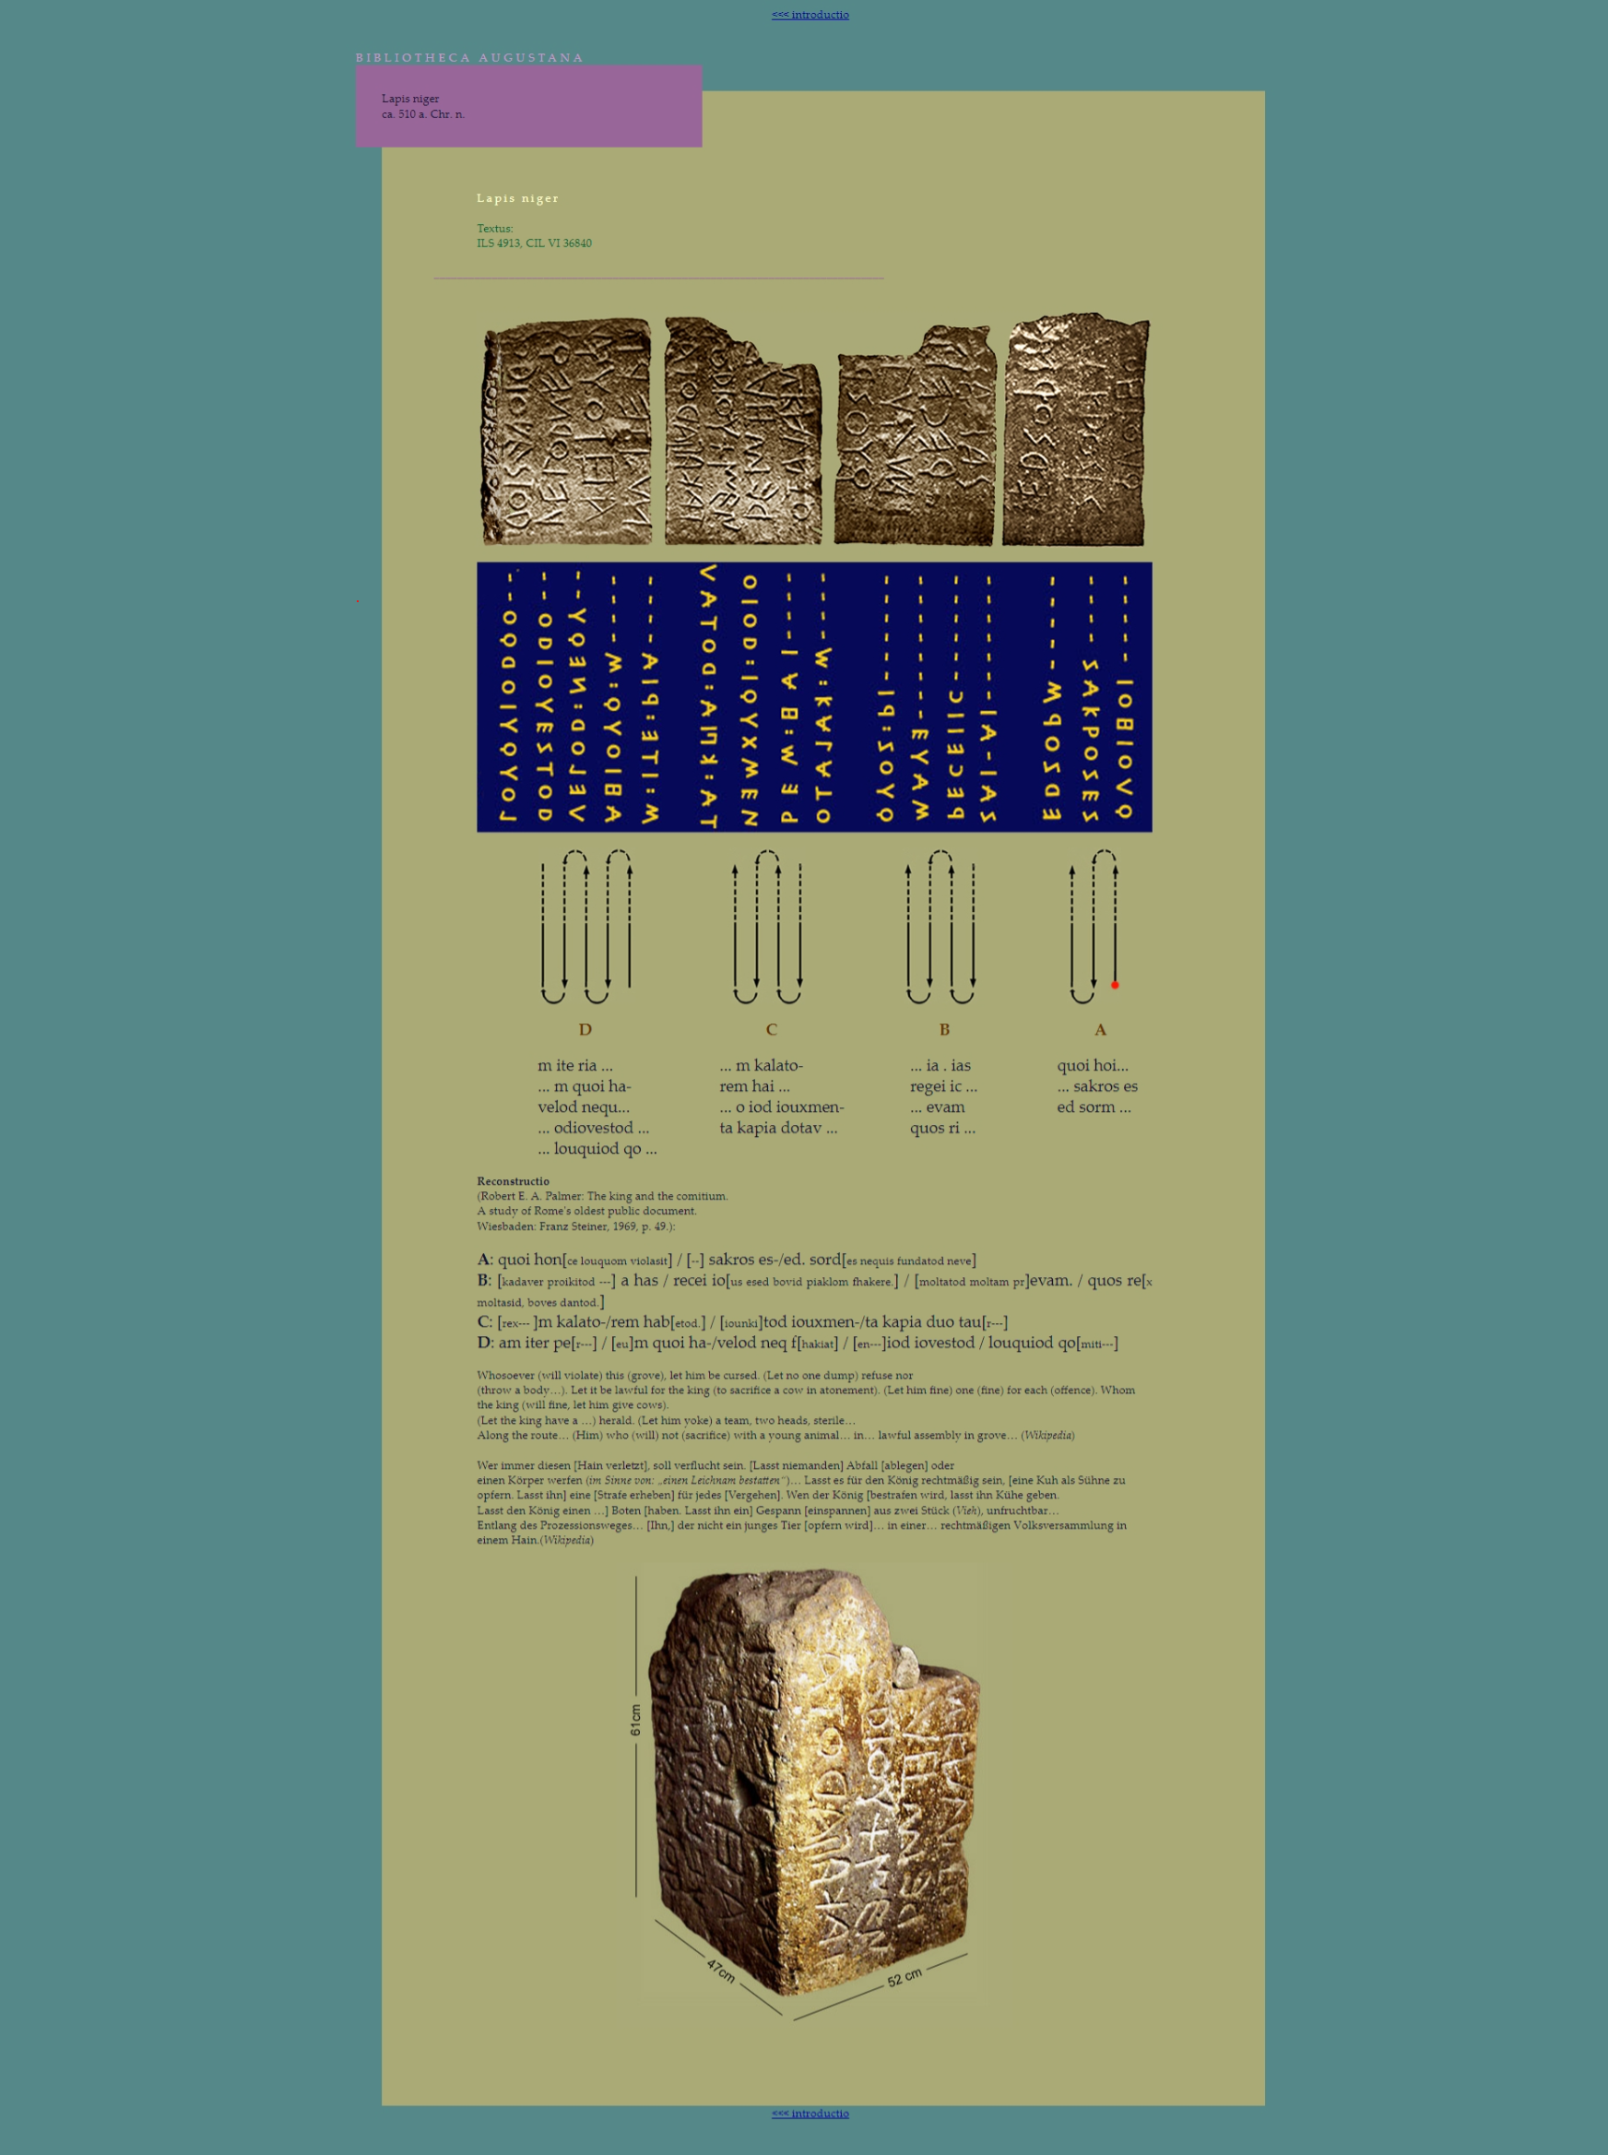

Figure 2 https://www.hs-augsburg.de/~harsch/Chronologia/Lsante06/Lapis/lap_cipu.html